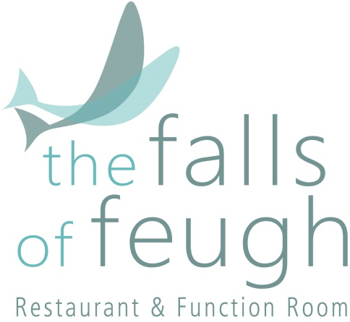

“There are few hours in life more agreeable than the hour dedicated to the ceremony known as
Afternoon Tea.”

Henry James

Afternoon Tea
TEA SELECTION
Breakfast Tea
Earl Grey
Darjeeling
Assam
Chai
Decaf
Green Tea
Peppermint
Camomile
Lemon & Ginger
Strawberry & Raspberry
Blackcurrant Burst
Mango & Cinnamon
Cranberry & Raspberry

COFFEE
Carora Fair Trade Ground Filter Coffee

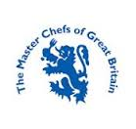
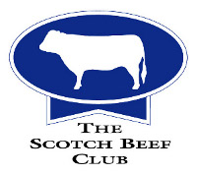

Assorted Sandwiches

The Falls Victoria Sponge

Ginger & Cinnamon Cookies

Chocolate Yule Log

Christmas Pudding Cheesecake

Plain Scones (Jam/Cream/Butter)

Spiced Doughnut

Biscoff Slice

Afternoon Tea £22.50

Prosecco Vitelli (20cl) £9.50
Nozecco 0% £7.00
Crémant de Loire £9.00

The Falls of Feugh Restaurant
Bridge of Feugh
Banchory, AB31 6NL
01330 824171
enquiries@thefallsoffeugh.com
www.thefallsoffeugh.com

