Dessert Menu
CRÈME BRULEE £7.50
Seville Orange Marmalade, White Chocolate & Madagascan Vanilla Bean,
House Shortbread, Chefs Homemade Sorbet

CHEESECAKE £7.50
Apple Crumble Cheesecake, Biscoff Base, Puree, Banana Ice Cream

STICKY TOFFEE PUDDING £7.50
Sticky Date Sponge, Toffee Sauce, Vanilla Ice Cream

CHOCOLATE TART £7.50
Warm 73% Madagascan Chocolate & Dark Matter Rum, Peanut Butter, Lime Curd,
Honeycomb Ice Cream

PANNACOTTA £7.50
Clotted Cream, White Chocolate & Amaretto, Berry Compote, Strawberry Sorbet, Tuille

PEAR TART £7.50
Chocolate & Caramel Pear, Berry Coulis, White Chocolate Ice Cream

ICE CREAMS & SORBETS £5.50

AFFOGATO £5.00
Vanilla Ice Cream, Espresso
Add Amaretto/ Baileys/Tia Maria £3.00
TEA/COFFEE & TABLET £3.95
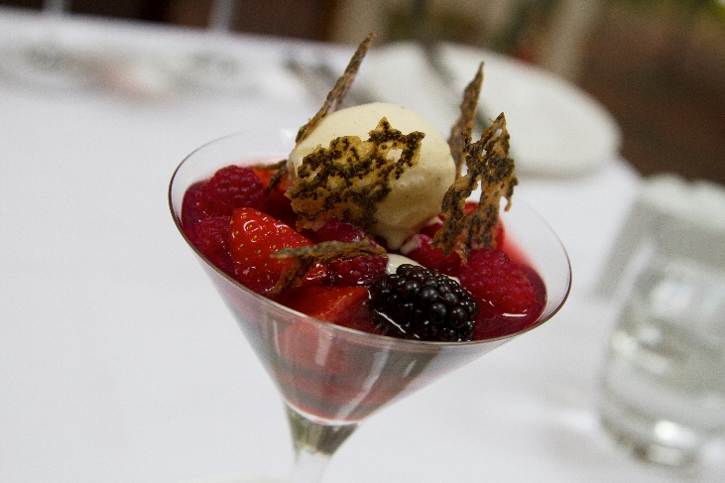
CASH IS KING
AS A SMALL BUSINESS WE GET CHARGED FOR EVERY CARD TRANSACTION
BY PAYING CASH WE RETAIN 100% OF ITS VALUE AND IT HELPS US TO KEEP OUR PRICES COMPETITIVE
PLEASE SUPPORT US BY PAYING CASH WHEREVER POSSIBL

