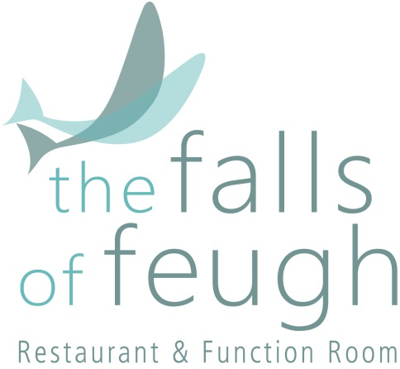

Afternoon Tea

“There are few hours in life more agreeable than the hour dedicated to the ceremony known as
Afternoon Tea.”

Henry James

TEA SELECTION
Breakfast Tea
Earl Grey
Darjeeling
Assam
Chai
Decaf
Green Tea
Peppermint
Camomile
Lemon & Ginger
Strawberry & Raspberry
Blackcurrant Burst
Mango & Cinnamon
Apple & Blackberry
Cranberry & Raspberry

COFFEE
Matthew Algie Ground Filter Coffee

(The content of each plate on the menu depends exclusively on the daily availability of fresh ingredients)

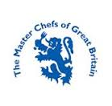
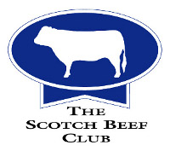

Assorted Sandwiches

The Falls Victoria Sponge

Ginger Cupcake

Chocolate Eclair

Tiffin

Plain Scones

Swiss Roll

Fudge Krispie

Dessert Shot

Afternoon Tea £18.50

Add a glass of:- Sherry £21.95
Wine £24.50
Fizz £28.50

The Falls of Feugh Restaurant
Bridge of Feugh
Banchory, AB31 6NL
01330 824171
enquiries@thefallsoffeugh.com
www.thefallsoffeugh.com

